LOAD BALANCER
Summary - A load balancer is a system that distributes incoming network traffic across multiple servers to ensure no single server is overloaded. It improves performance, reliability, and availability of applications by balancing the workload and redirecting traffic if a server fails.
- Configure Classic Load balancer
Create 2 instances in same region with the names server 01 and select subnet 1a to server 1 and 1b to server 02 and add the script of httpd on both the servers and launch instances
instance 01
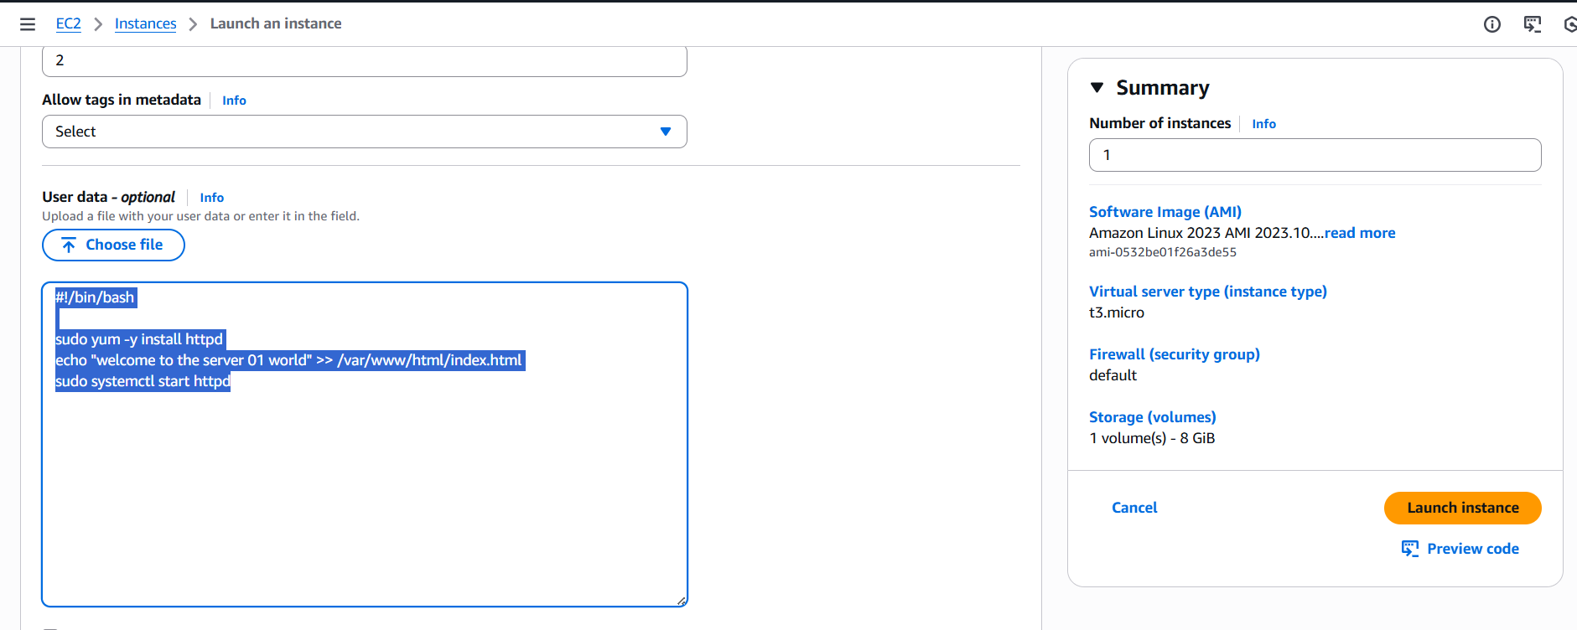
Instance 02
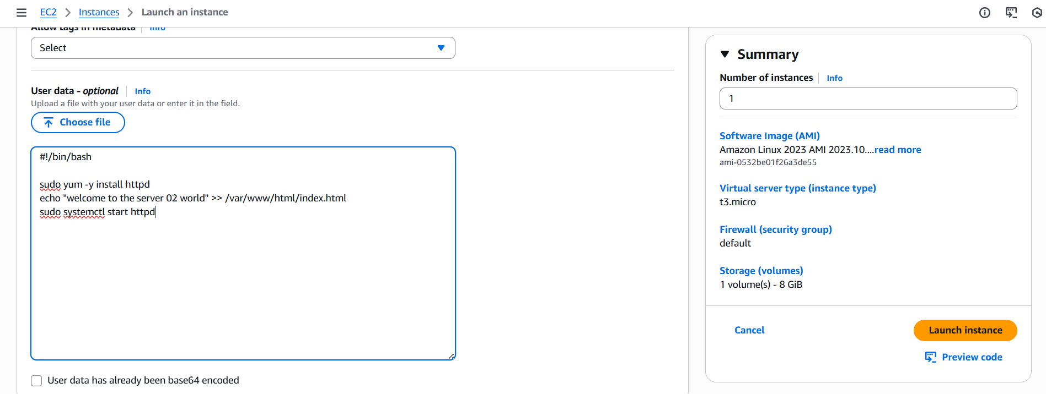
And test it is working or not
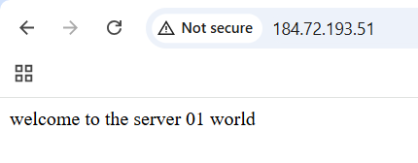
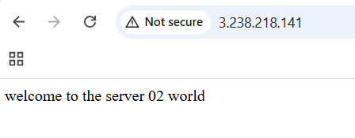
Now we need to create the load balancer open load balancer and click on create classic load balancer
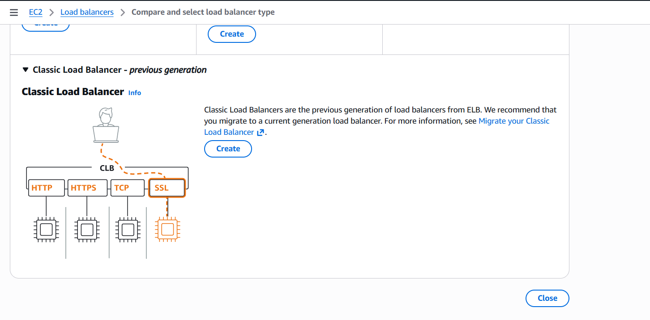
Add load balancer name and select vpc and select 2 different regions subnets and then click on load balancer
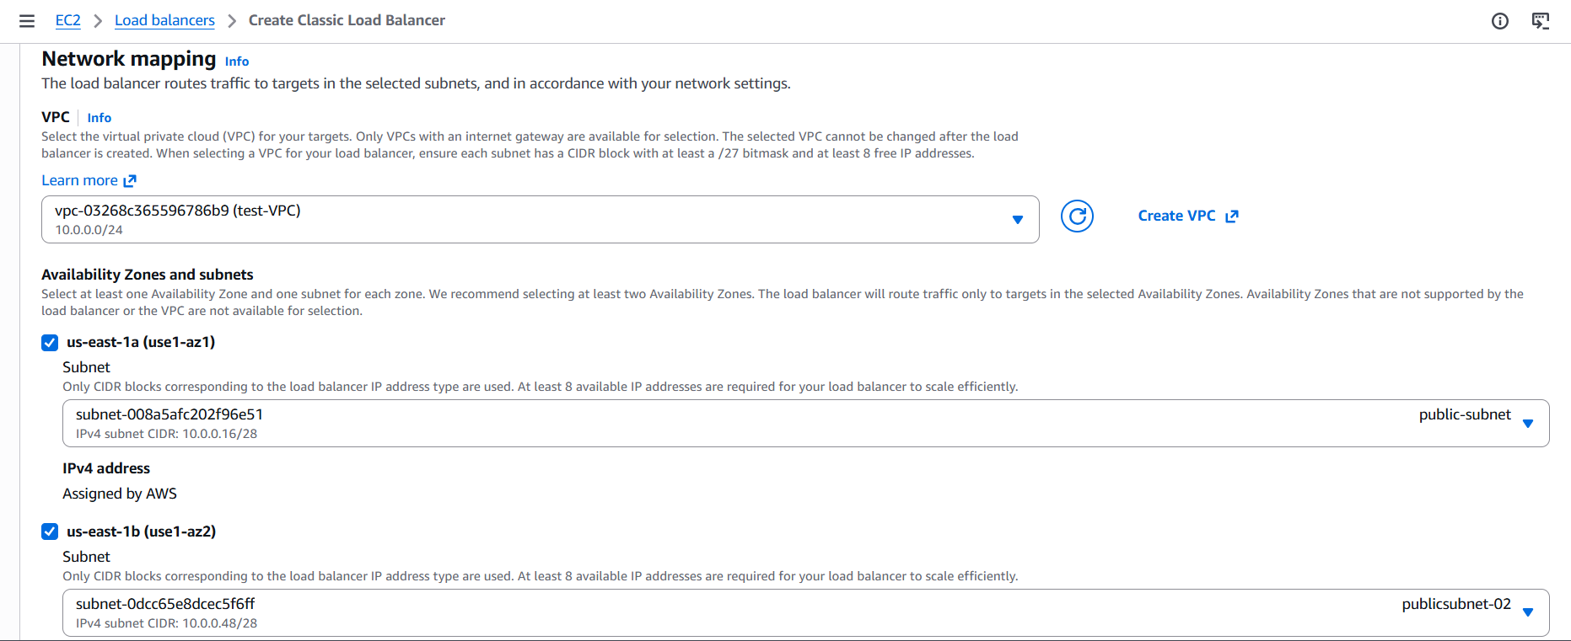
Now got to load balance then click on target instances and select the instances we want to add and then save changes
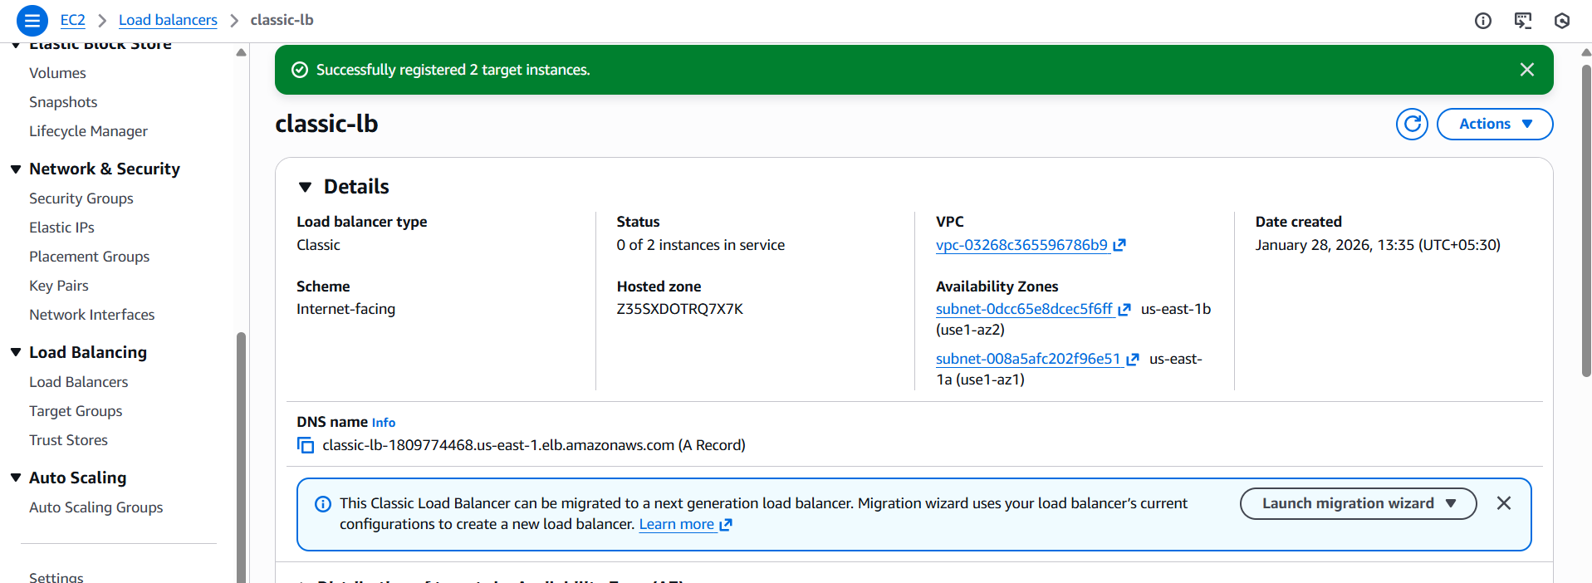
And check the health check
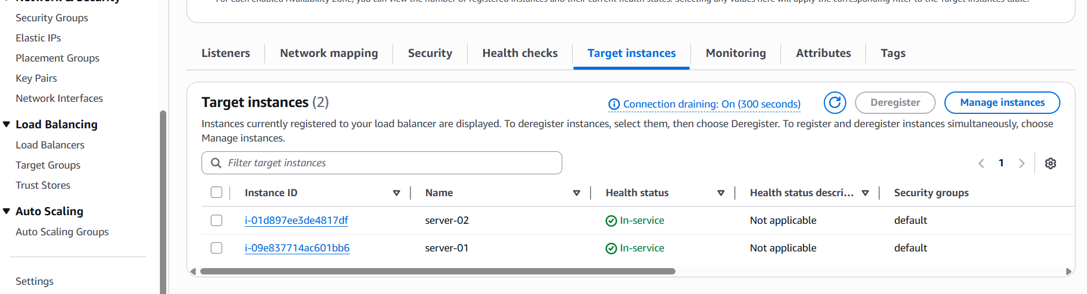
Now go to load balancer and copy the DNS name then paste in on browser
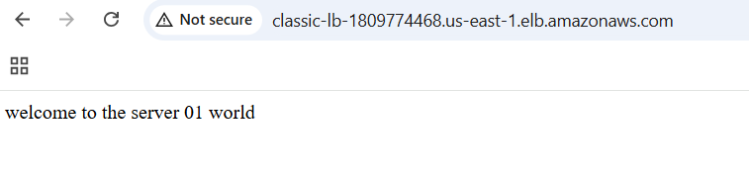
And refresh the page to see the server 02
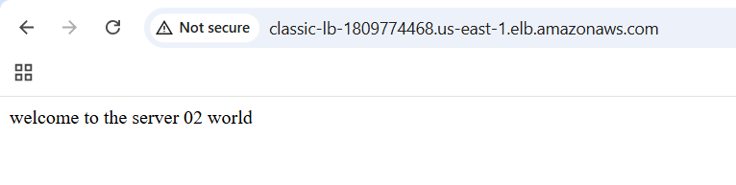
- Configure Application Load balancer
Go to load balancer and create load balancer and select application load balancer, create and provide the name and attach vpc and 2 subnets of different region
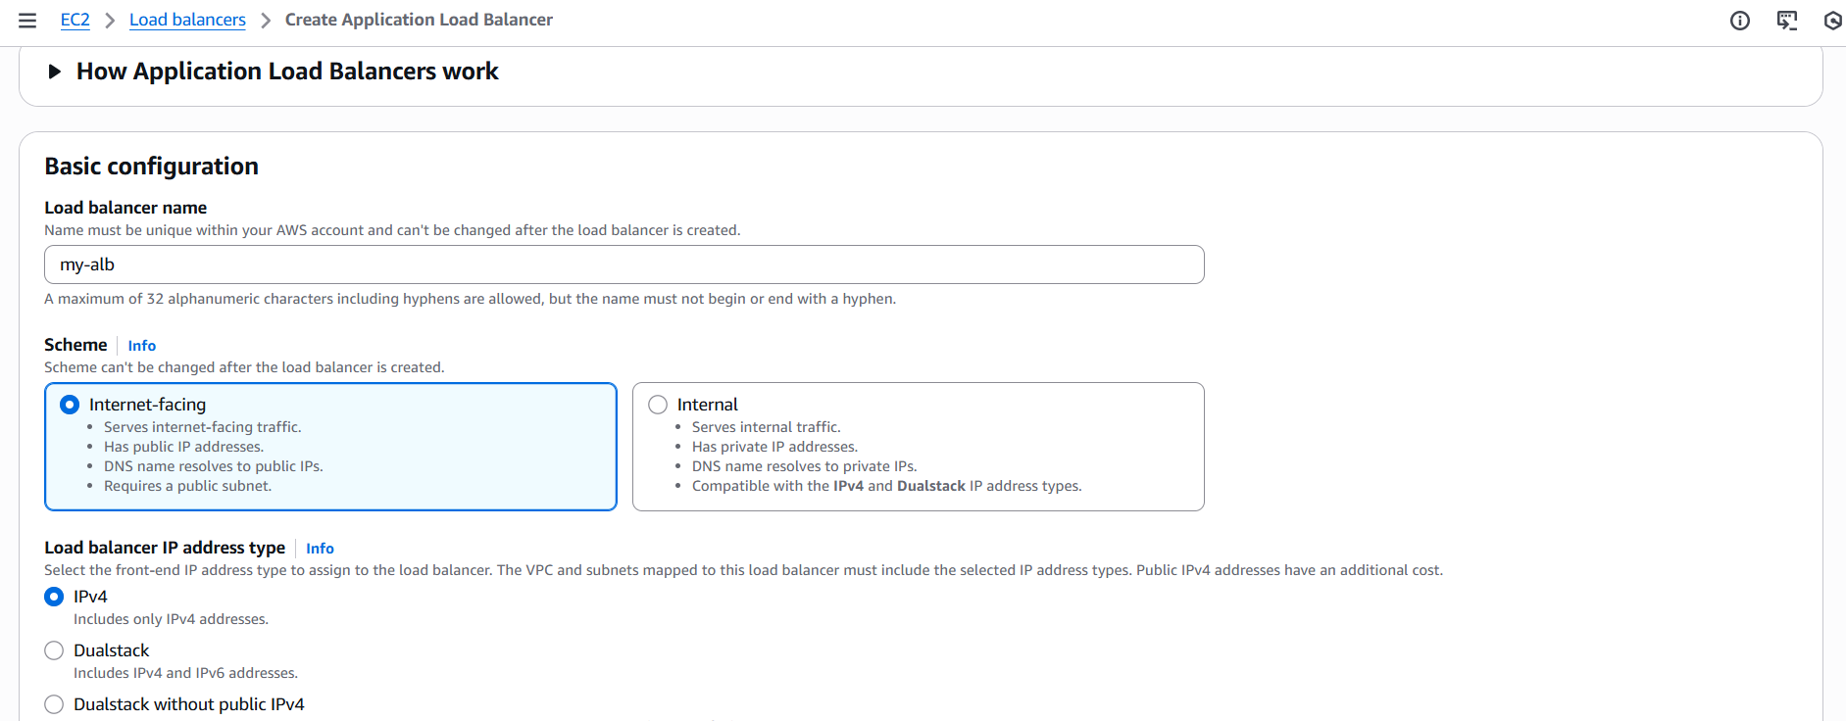
And in listeners and routing create a target group and click on next
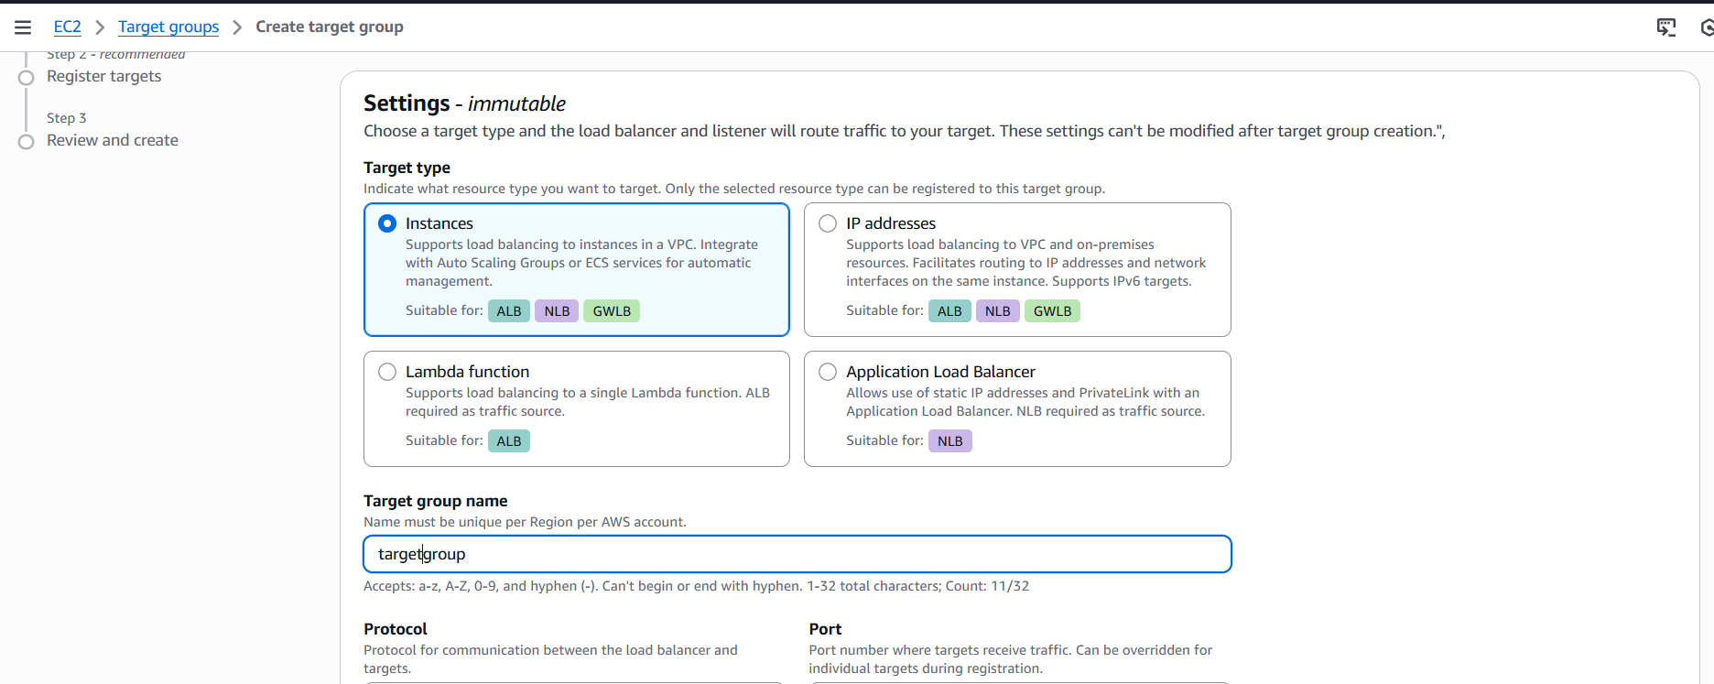
Select our instances and click on include as pending below and click on next and create
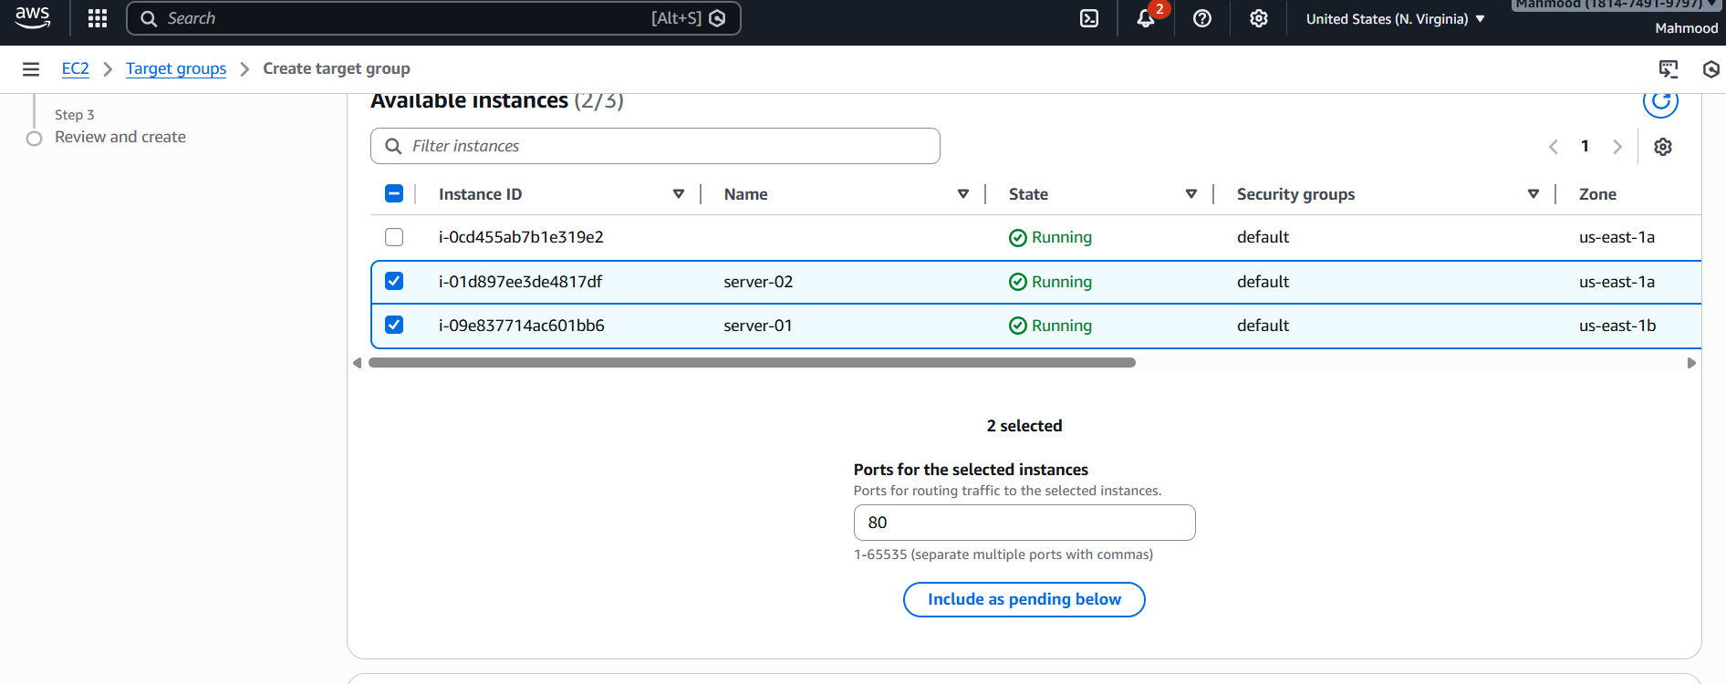
And select target group in load balancer and create load balancer
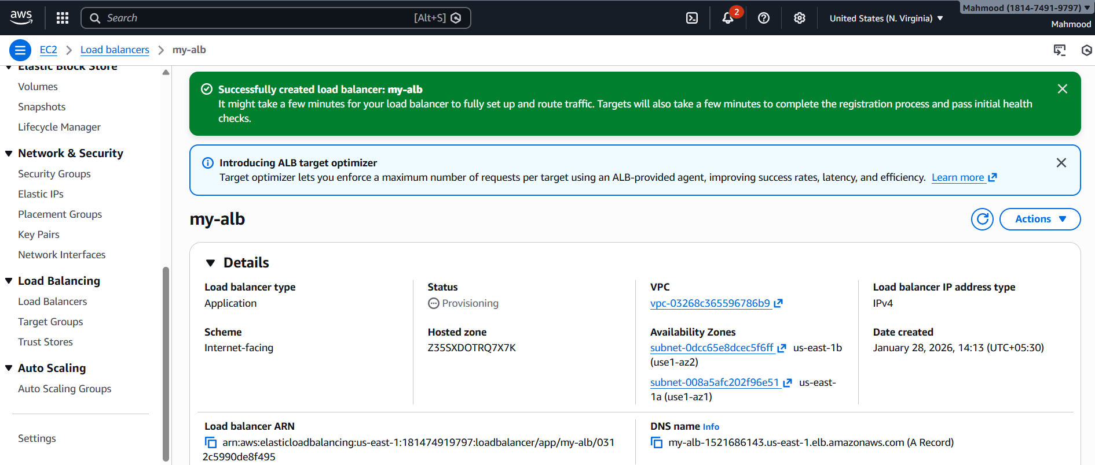
And copy the DNS and paste It on browser
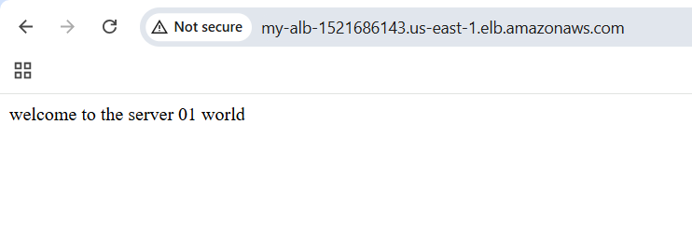
Refresh it
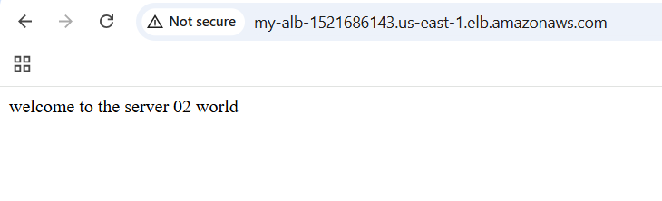
- Configure Network Load balancer
Go to load balancer click on create network load balancer
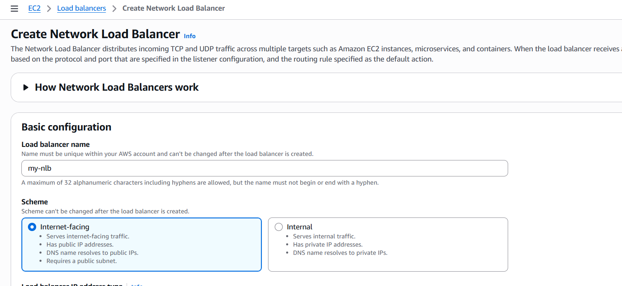
And create target group with name of nlb and attach in target group then create load balancer
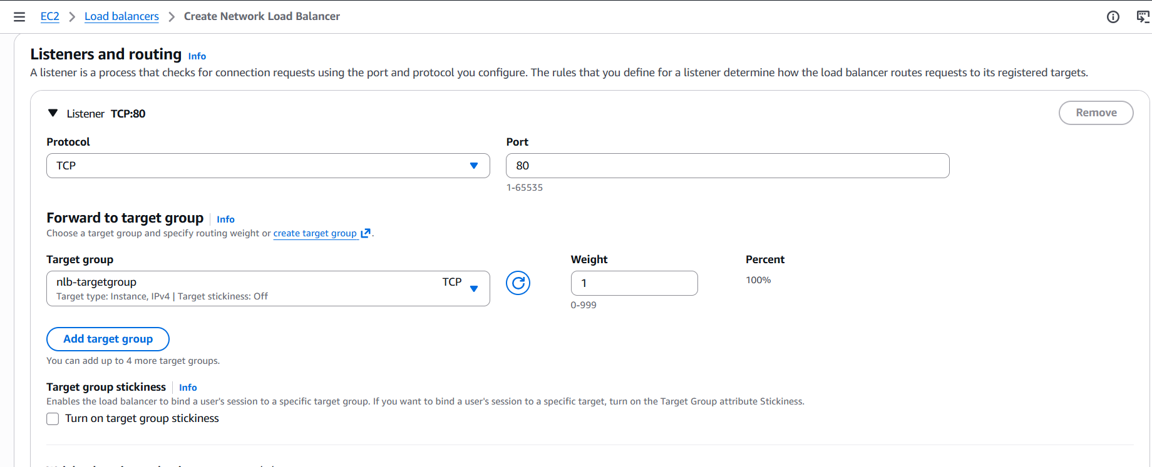
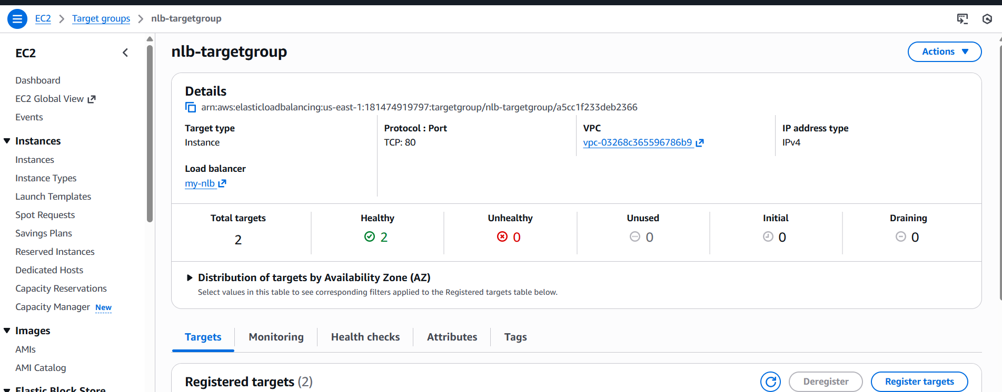
Now go to network load balancer and copy the DNS name paste it in browser
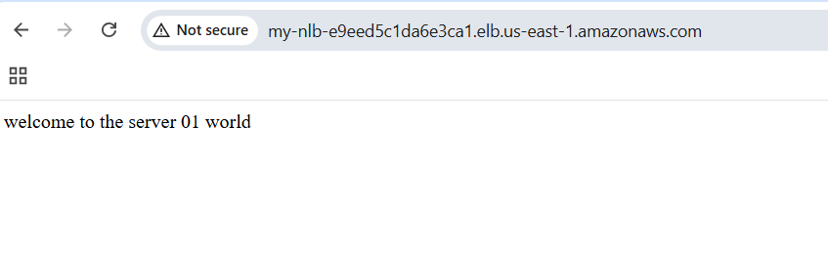
- Attach SSL for application load balancer
Go to AWS console and search certificate manager and click on it and click request a certificate and public then next
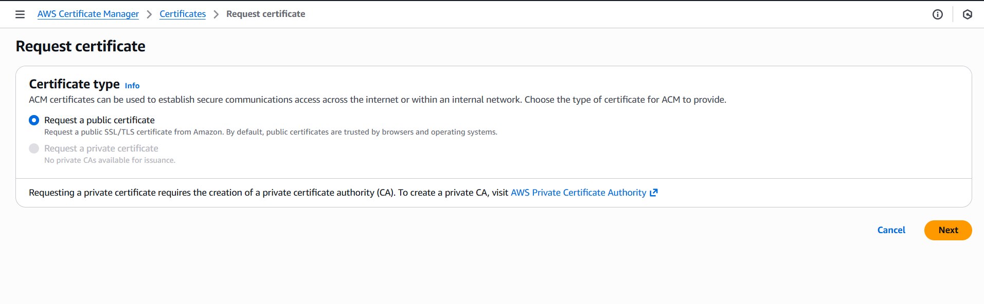
Then provide the domain name and click request
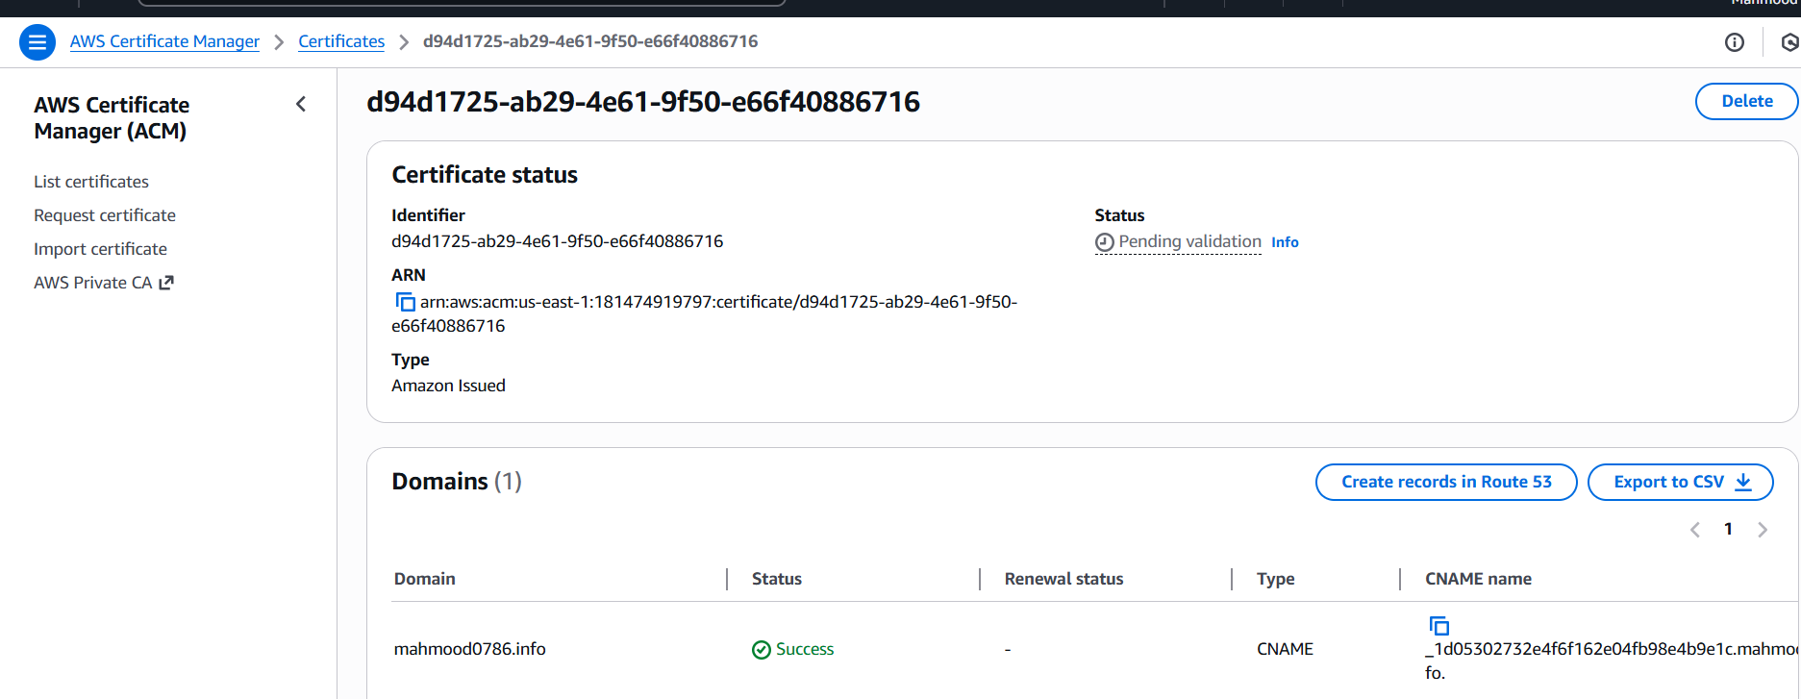
Now go to route 53 and check domain already created or create a new domain and I have domain already created previously I am attaching that
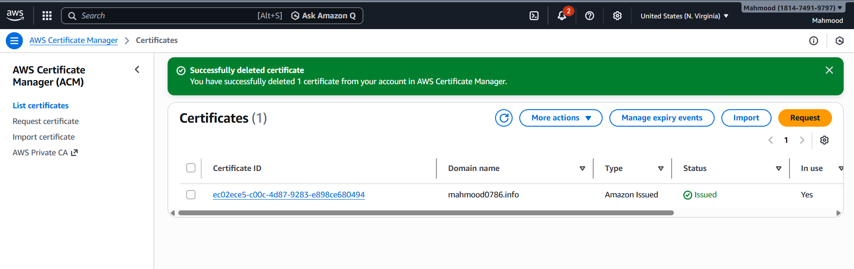
And click on load balancer and in default ssl add the certificate
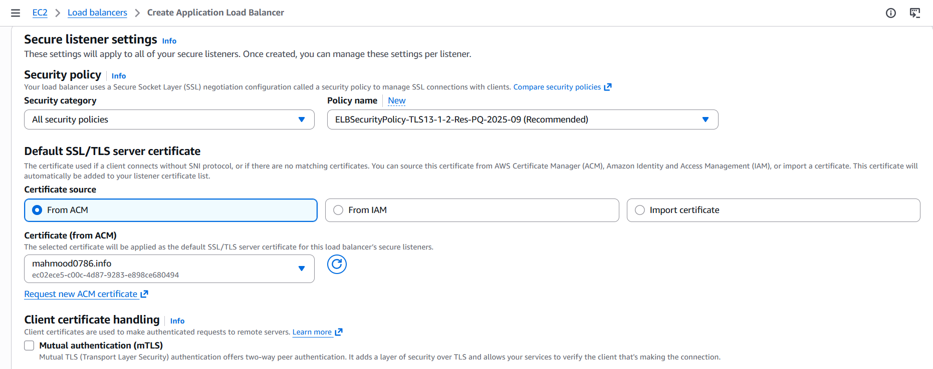
Now we need to go to route 53 and create a record
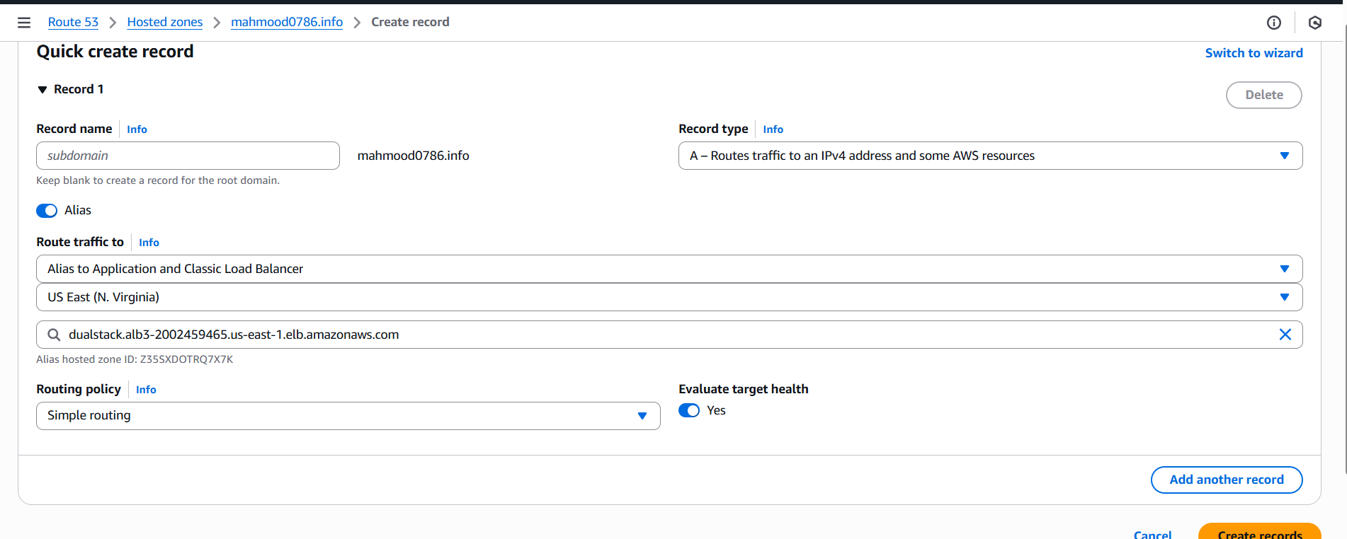
Then paste the domain id in browser
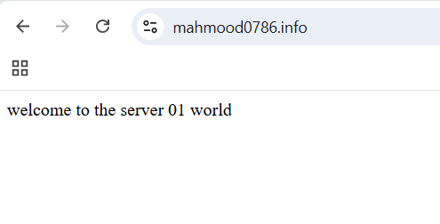
Refresh
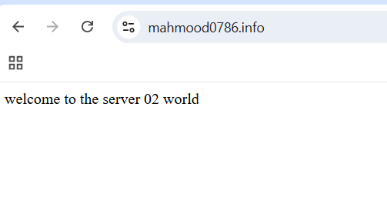
- Map Application load balancer to R53
Go to route53- hosted zones and select the record
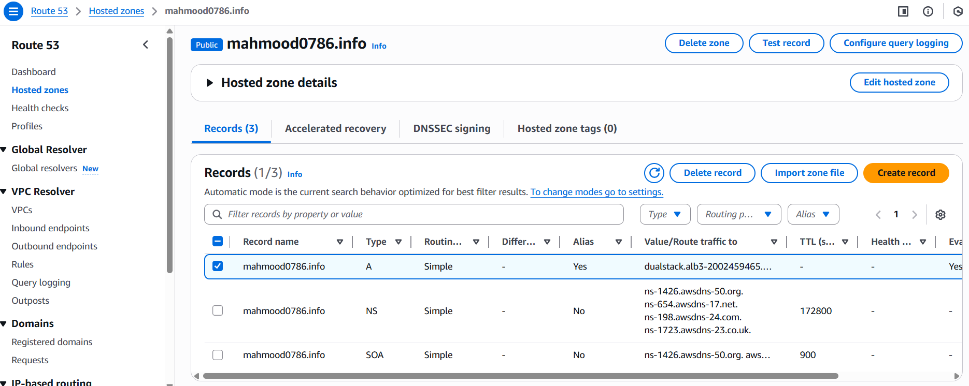
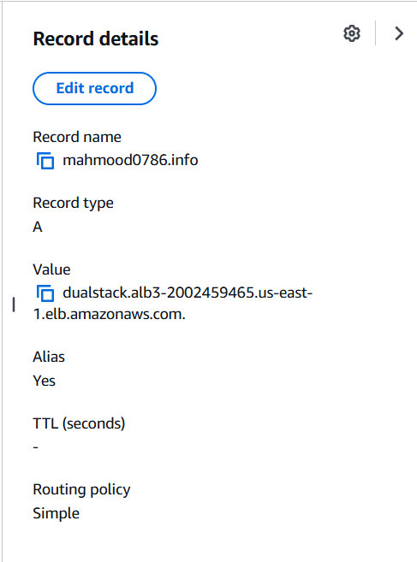
- Push the application load balancer logs to S3
Create an s3 bucket and attach s3 bucket policy
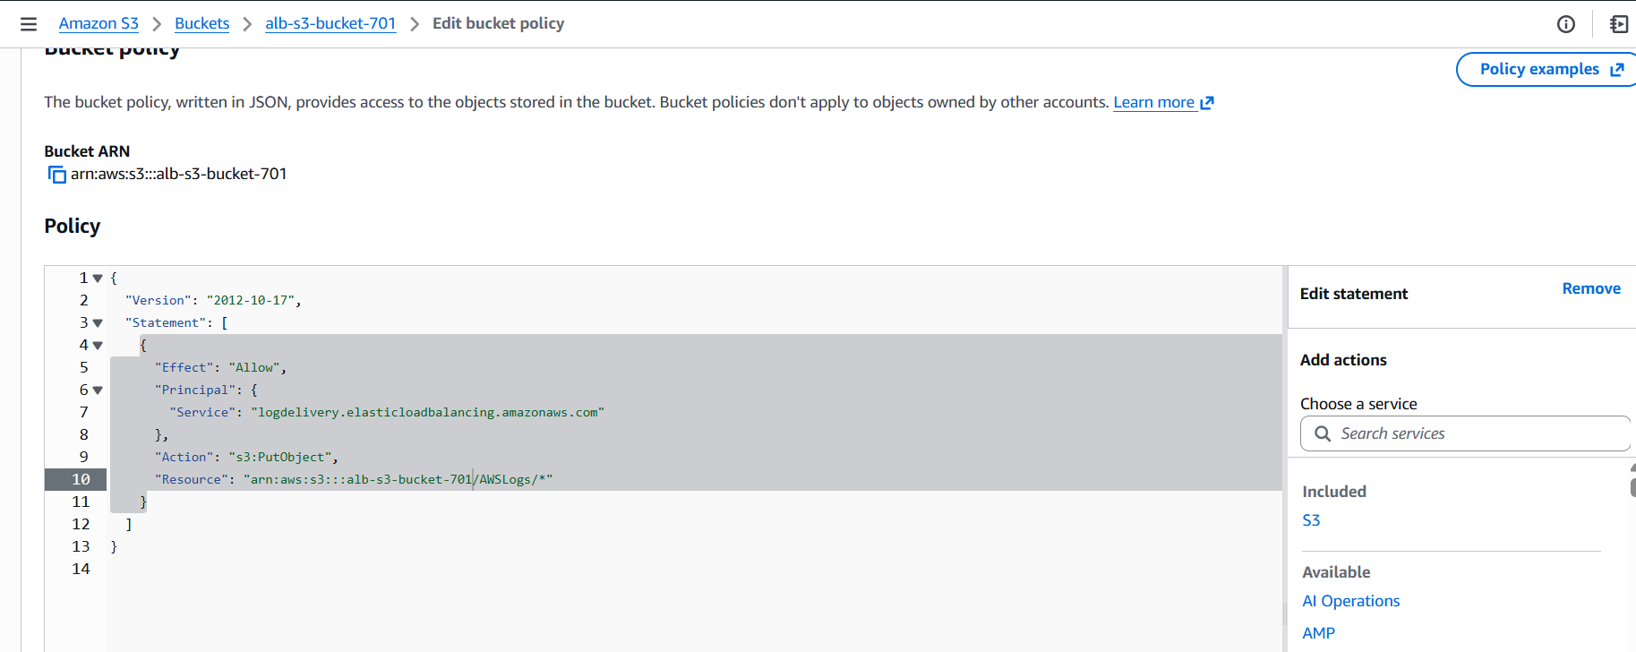
Now go to load balancer and select alb3 load balancer and click on attributes then click on edit and add bucket name and save changes
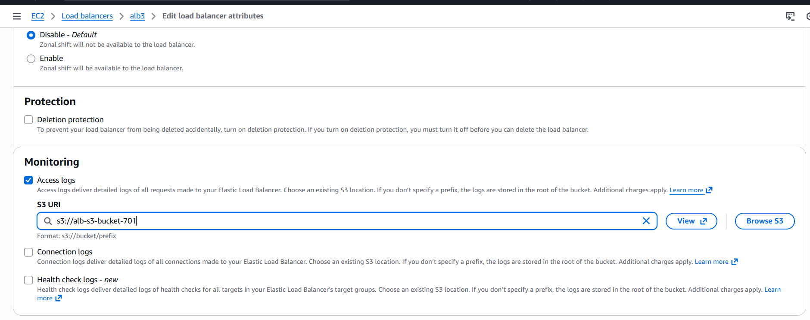
And go to s3 bucket click on bucket
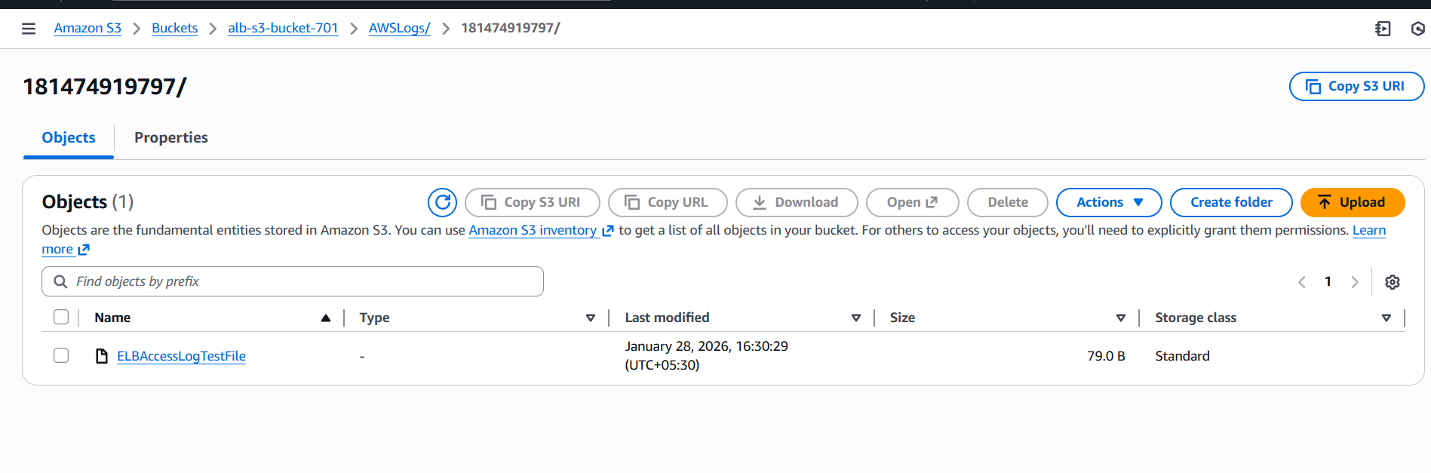
- Issue faced – while attaching application to load balancer, in my account domain is already created and again I have duplicate the domain with the same and I got confused then I have seen one domain is in use and other is not in use so I deleted the not in use domain and moved forward and attach ssl and created a new record and output is successfully executed
- Conclusion- configured classic, application and network load balancer and attach ssl to application load balancer then mapped it to R53 and pushed the application load balancer logs to S3

